Commander Victor M. Barba

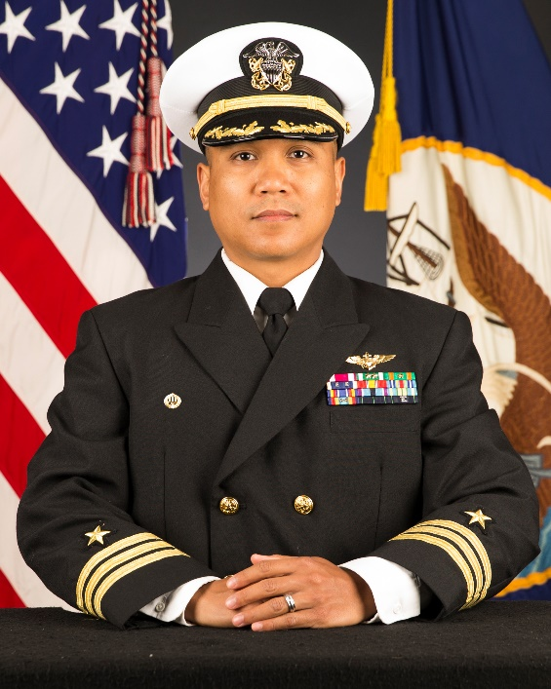
Cmdr. Victor Barba is a native of Oxon Hill, Md. and graduated from the University of Maryland, College Park with a Bachelor of Science in Aerospace Engineering and received his commission through the Naval Reserve Officer Training Corps program through George Washington University in 2006. In 2007, he earned a master’s degree in aeronautical engineering from the Air Force Institute of Technology in Dayton, Ohio.

He was designated a Naval Aviator in 2009 and reported for his initial sea tour at Helicopter Sea Combat Squadron (HSC) 26, completing two combat logistics deployments in the U.S. 5th Fleet area of responsibility (AOR). Subsequent sea duty assignments include aircraft launch and recovery officer (shooter) on PCU Gerald R. Ford (CVN-78) and department head at Helicopter Sea Combat Squadron (HSC) 22. He served as the officer in charge of helicopter detachments embarked on the Mercy-class hospital ship USNS Comfort (T-AH 20) in support of humanitarian assistance and disaster relief in Puerto Rico, and on the Lewis and Clark-class dry cargo ship USNS Medgar Evers (T-AKE 13) providing combat logistics in the U.S. 6th Fleet AOR. In his final position at HSC-22, Barba served as the maintenance officer, preparing the first operational MH-60S Sea hawk helicopter and MQ-8 Fire Scout composite deployment in support of U.S. 4th Fleet operations.

Ashore, Cmdr. Barba served as an advanced helicopter instructor pilot at Helicopter Training Squadron (HT) 28, where he was the assistant operations officer. He also served as the MQ-8 integrated transition team officer in charge at Helicopter Sea Combat Wing, Pacific, leading the MQ-8C Fleet Introduction and the accelerated sundown of the MQ-8B.

He is currently serving as the commanding officer of Cooperative Security Location (CSL) Comalapa, El Salvador.

Barba’s military awards include the Meritorious Service Medal, Navy Commendation Medal (3 awards), Navy Achievement Medal (2 awards), and various unit, campaign, and service awards. He has flown more than 2800 hours in fixed-wing, rotary-wing, and unmanned aircraft.

